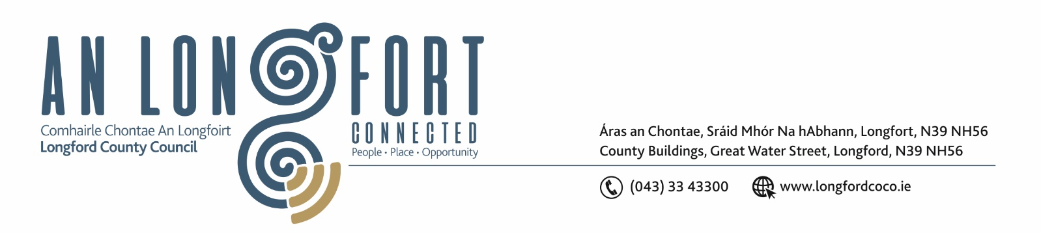

Please Note Venue for Meeting – Longford Rugby Club.

3u Meán Fómhair 2020.

Chuig: Gach Ball don Chomhairle.

A Chomhairleoir,

Iarrtar ort bheith i láthair ag Cruinniú Chomhairle Chontae Longfoirt a tionólfar i
Club Rugbaí Longfort ar an Chéadaoin, 9u Meán Fómhair 2020 ag 3.00 p.m chun gnó a dhéanamh d’réir an Chláir thíos.

You are requested to attend Meeting of Longford County Council to be held in
Longford Rugby Club, Demesne, Longford on Wednesday, 9th September 2020 at
3.00 p.m. to transact business, as set out on the Agenda hereunder.

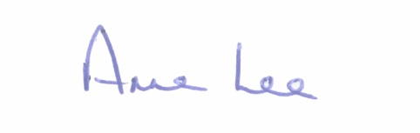
Mise le meas,

__________________
Anne Lee,
Meetings Administrator.

C L A R

Prayer before meeting.

- Confirmation of Minutes of the following meetings of Longford County Council-

- Annual Meeting held on the 26th June 2020
- July Meeting held on the 8th July 2020
- copies enclosed.
- Matters arising from Minutes.

- Declaration of Interest by Members.

- To note Chief Executive Report - to follow.

5. To note adopted Minutes of Corporate Policy Group Meeting held on
10th June 2020 - enclosed.

6. Finance and Regeneration.

- To note adopted Minutes of meeting of Governance Strategic Policy
Committee held on the 29th January 2020 - enclosed.

(b) To consider the Local Property Tax Variation in accordance with the provisions of Section 20 of the Finance (Local Property Tax) Act 2012.

(c) To fix dates for the following Meetings -
- Municipal District Meetings to consider draft Budgetary Plan for 2021.
- Longford County Council Finance Committee meeting to consider 2021 Budget.
- Longford County Council Statutory meeting to consider 2021 Budget.

(d) Consideration of the disposal of site at the IDA Business Park, Ballinalee
Road, Longford in accordance with the terms of Section 183 of the Local Government Act 2001 issued on the 24th August 2020.

(e) Approval to the appointment of Ms. Brid Mimnagh to Longford County
Council Audit Committee to replace Councillor Uruemu Adejinmi.

(f) Notices of Motions, submitted by Councillors, as listed hereunder -

Councillor Uruemu Adejinmi

“I call on the Council to initiate a Participatory Budgeting (PB) Exercise for
the people of Longford County. PB is a process in which the public can participate directly in the allocation of local public finances wherein residents develop project proposals for their local area and vote on shortlisted proposals in order to select winning projects to be implemented in the area.

South Dublin County Council (SDCC) piloted the first ever PB process in Ireland in 2017 (branded “€300k – Have Your Say”). SDCC allocated €300,000 to the PB process and selected one of 6 local electoral areas in South Dublin County by lot in which to pilot the project. The area selected was the Lucan electoral area, which also includes Palmerston and Adamstown.”

- Community, Corporate and Enterprise.

- To note adopted Minutes of meeting of Placemaking Strategic Policy
Committee held on the 27th January 2020 - enclosed.

- Approval to the appointment of Sectoral Representative to the following
Strategic Policy Committee –
- Governance SPC - Karie Murray.

- Approval to the appointment of the following members to Longford Community
Development Committee (LCDC) –

- Mr. Bartle D’Arcy, nominee of the Co. Longford Tourism Committee to replace Mr. Seadna Ryan.
- Mr. Emmet Duffy, nominee of the Farming Pillar/ Irish Farmers’ Association to replace Mr. Sean Hannon.

- Preparation of Register of Electors 2021/2022.

- Date for October meeting of the Council.

8. Strategic Infrastructure and Climate Change.

- To note Planning Applications received since last meeting of the Council.

- (i) To note adopted Minutes of meeting of Climate Action and Planning
Strategic Policy Committee held on the 21st January 2020 - enclosed.

(ii) To note adopted Minutes of meeting of Strategic Infrastructure
Strategic Policy Committee held on the 3rd February 2020
- enclosed.

- Date for Committee Meeting of Longford County Council to consider
Pre-Draft County Development Plan 2021 – 2027.

- Notice of Motion submitted by Councillor Paraic Brady.

“I call on Longford County Council’s Roads Section to provide speed
restrictions and traffic calming measures in all the small towns and villages
in the County.”

9. General.
- Notices of Motions, submitted by Councillors, as listed hereunder –

Councillor Mark Casey.
“That Longford County Council calls on the Government to deliver on a 2008 Labour Court ruling to provide pension entitlement to supervisors on Community Employment schemes in the state. The Governments inaction on the 2008 decision is totally undermining the Labour Court and causing undue hardship to supervisors that made no alternative arrangements on foot of this historical Court decision.”

Councillor Gerry Warnock.
“I am calling on Longford County Council and Longford Joint Policing Committee to write to the Minister for Justice and the Minister for Public Expenditure to make provisions where monies confiscated under the Proceeds of Crime legislation be redirected from central coffers to a local fund where local groups involved in addiction services, youth activities and community initiatives can avail of much needed revenue options to help them in their work to counter the negative impact of criminality on the local stage.”

Councillor Uruemu Adejinmi.

“For Longford County Council to call on the Irish Government Departments of Health, Justice and Equality and Children and Youth Affairs to recognise that Parental Alienation is “Substantial and sustained dissatisfaction within a caregiver-child relationship associated with significant disturbance in functioning” as coded by the World Health Organisation in the latest International Classification of Diseases version 11 and to implement recommendation 36 of the Report of the Reform of the Family Law System October 2019.”

10. Training -
Consideration of Report from Corporate Policy Group.

11. Votes of sympathy.



